**SECTION A (60 Marks)**

Answer only **three** questions from this section.

1. **6.0g** of bromoalkane, **P CnH2n + 1Br** contains **65.04%** by mass of bromine.
2. Determine the molecular formula of bromoalkane, **P**. (03 marks)
3. Write the **structural formulae** and **IUPAC names** of all the possible isomers of bromoalkane, **P**. (02 marks)
4. When bromoalkane, **P** is refluxed with aqueous potassium hydroxide solution, Compound, **Q** is formed. Compound, **Q** formed two layers after five minutes when treated with a mixture of concentrated hydrochloric acid and anhydrous zinc chloride. Identify bromoalkane, **P** and compound, **Q**. (02 marks)
5. Write equations and suggest mechanism for the reaction of bromoalkane**, P** and:
6. Alkaline solution of phenol. (03 marks)
7. Hot solution of potassium hydroxide in ethanol. (03 marks)
8. Using equations show how bromoalkane, **P** can be converted to 2-**methylpropan-2-ol**. (04 marks)
9. Name the **reagent** that can be used to distinguish between bromoalkane, **P** and compound, **Q**, State what would be observed when the reagent is treated with each compound. (03 marks)
10. a) What is meant by the following terms? (@01 mark)
11. **Freezing point.**
12. **Freezing point depression.**
13. (i) Describe an experiment that can be carried out to determine the relative molecular mass of a substance by freezing point method.(Diagram **NOT** required) (06 marks)

(ii)Explain why freezing point method is not suitable for determination of relative molecular mass of benzoic acid in benzene. (03 marks)

1. The **table** below shows the freezing points of various solutions of cane sugar in solvent, **X**.

|  |  |  |  |  |  |  |  |
| --- | --- | --- | --- | --- | --- | --- | --- |
| Mass of cane sugar in 1,000g of X | 26 | 42 | 66 | 78 | 118 | 148 | 173 |
| Freezing point (ᵒC) | 5.11 | 4.87 | 4.51 | 4.33 | 3.73 | 3.28 | 2.90 |

1. Plot a graph of freezing point against mass of cane sugar. (03 marks)
2. Use the graph to determine freezing point of solvent, X and freezing point constant if the relative molecular mass of cane sugar is **342**. (03 marks)
3. **250g** of water contains **0.1 mole** of a non-volatile solute. Calculate the mass of ice deposited when the solution is cooled to **3.72ᵒC**.The freezing point constant for water is **1.86ᵒC/mol/kg**. (03 marks)
4. (a).Define the term **first electron affinity**. (01 mark)
5. The first electron affinities of group (VII) elements are given in the table below:

|  |  |  |  |  |
| --- | --- | --- | --- | --- |
| Elements | F | Cl | Br | I |
| Electron affinities (KJ/mol) | -328 | -364 | -325 | -295 |

1. Explain the **trend** of the first electron affinities of the elements. (03 marks)
2. **Fluorine differs** from the rest of the elements. State **three** **reasons** for the anomalous behavior of fluorine. (03 marks)
3. Describe the reactions of:
4. Fluorine, chlorine and bromine with **sodium hydroxide solution**. (06 marks)
5. **Hydrides** of group (VII) elements with **concentrated sulphuric** acid. (04 marks)
6. A solution containing **chlorate (V) ions** and **dilute sulphuric** acid was added to a solution containing **iodide ions**. Explain what was observed?

(03 marks)

1. a) State what is meant by the term **ideal solution**? (02 marks)

b) Methanol and ethanol form an ideal solution. At **27ᵒC**, the vapour pressure of methanol and ethanol are **11.82kPa** and **5.93kPa**.Calculate:

1. the **mole fraction** of ethanol in the vapour above a liquid mixture made of equal moles of ethanol and methanol at **27ᵒC**. (03 marks)
2. the **mole fraction** of ethanol in the liquid solution when the mole fractions of ethanol and methanol in the vapour are equal. (03 marks)

c) the **boiling points** of liquids ethanol and methanol are **78.5ᵒC** and **64.7ᵒC** respectively.

1. Sketch a labelled **boiling point-composition diagram** of the mixture of the liquids. (03 marks)
2. Using the d**iagram**, describe how **pure ethanol** can be obtained from a mixture containing **50%** of ethanol. (05 marks)
3. If the mixture of ethanol and methanol in (b) was to deviate negatively from Raoult’s law, Sketch a labelled **boiling-composition diagram** for the mixture. (02 marks)

**SECTION B (40 Marks)**

Answer only **two** questions from this section.

1. Using equations show how the following conversions can be made. Indicate the conditions and reagents for each reaction.
2. Benzene from chlorobenzene. (04 marks)
3. But-2-yne from butan-2-ol. (04½ marks)
4. Propanone from propan-1-ol. (05 marks)
5. Butane from ethanol. (02 marks)
6. Ethanaloxime from ethene. (04½ marks)
7. (a) (i) Define the term **buffer solution**. (01 mark)

(ii)**10cm3** of **0.1M** hydrochloric acid was added to **1dm3** of a **1M** propanoic acid of **pKa = 4.9** and **1M** sodium propanoate. Calculate the **pH** of the resultant solution. (05 marks)

(b)The table below shows the variation in pH when **30cm3** of **0.2M** ammonia solution was titrated with hydrochloric acid.

|  |  |  |  |  |  |  |  |  |  |  |  |  |
| --- | --- | --- | --- | --- | --- | --- | --- | --- | --- | --- | --- | --- |
| Volume of HCl added (cm3) | 0 | 4 | 8 | 12 | 16 | 19 | 19.4 | 20.2 | 21 | 22 | 26 | 28 |
| pH | 10.8 | 9.9 | 9.4 | 9.1 | 8.7 | 8.0 | 7.8 | 3.9 | 3.2 | 2.9 | 2.5 | 2.4 |

1. Plot a graph of **pH** against **volume** of hydrochloric acid. (03 marks)
2. Use the graph to determine the:

* pH and volume at the end point. (01 mark)
* Molarity of hydrochloric acid. (02 marks)
* Hydrolysis constant of ammonium chloride formed at the end point. (03 marks)
* Ratio of [NH4Cl]: [NH3] when **10cm3** of hydrochloric acid has been added to ammonia solution. (02 marks)

[Kb = **1.78 x 10-5 mol/dm3**, Kw = **1.0 x 10-14 mol2/dm6**]

1. Explain the **shape** of the graph. (04 marks)
2. Beryllium, magnesium, calcium, strontium and barium are elements in group (II) of the periodic table.
3. Describe the **reaction** of the elements with:
4. Water (03½ marks)
5. Oxygen (03 marks)
6. Bromine (02 marks)
7. Dilute hydrochloric acid (03½ marks)
8. State the **reasons** why beryllium differs from the **rest** of the other group (II) members. (03½ marks)
9. (i) Name the **reagent** that can be used to distinguish between calcium and barium ions. (01 mark)

(ii)State what would be observed and write equation (s) for the reaction(s) that would take place if the reagent you have named in (c) (i) was treated separately with calcium and barium ions. (03½ marks)

1. Explain each of the following observations.
2. The boiling point of butan-1-ol and ethoxyethane are **124ᵒC** and **35ᵒC** respectively yet they have the same molecular mass. (04 marks)
3. A solution of phenol turns moist blue litmus pare red while that of phenylmethanol has no effect on litmus. (04 marks)
4. Aluminium fluoride has ahigher melting point than aluminium chloride. (04 marks)
5. Ammonia solution forms a white precipitate with manganese (II) ions but in the presence of ammonium chloride, No precipitate forms. (05 marks)
6. When silver nitrate solution is added to a solution of iron (II) sulphate, the solution turns from green to yellow. (03 marks)

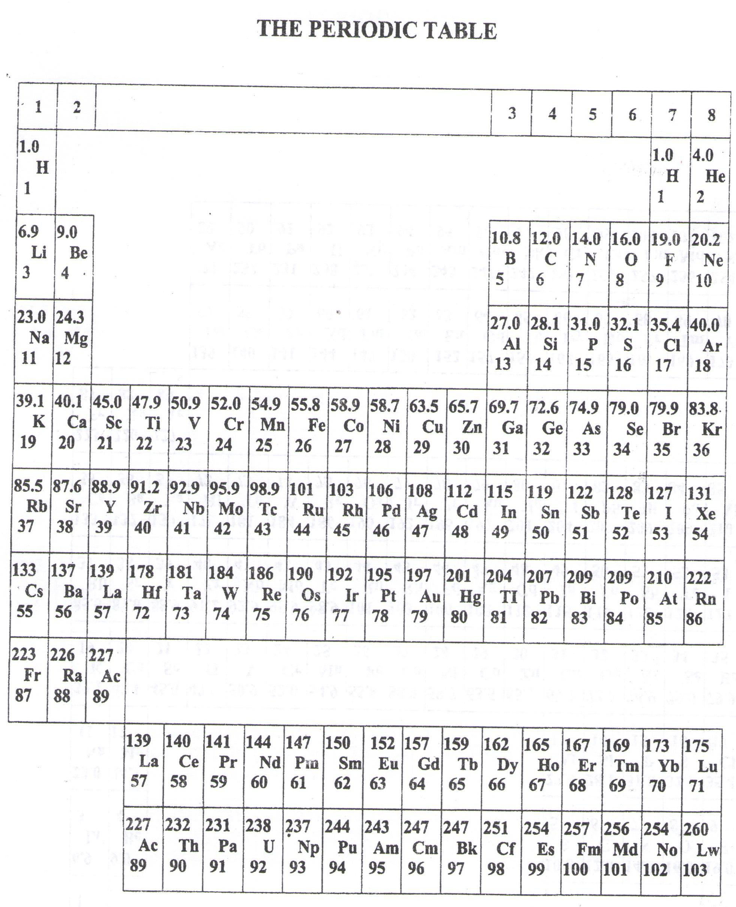

* ===END===

WELCOME TO SENIOR SIX, YEAR 2023

This is the last page of the printed paper, Page 05